Shortify API Documentation
The Shortify API collection provides a comprehensive set of data analytics for interacting with the application’s link shortening and graphing mechanisms.
The core mission of this architecture is to help users with shortening their links, and provide them with data analytics.
This collection includes endpoints for:
- Posting up a link to shorten
- Receiving data analytics
- Redirecting to target destination

Endpoints
POST Shorten a link
- Method: POST
- Endpoint: /api/v1/shorten
- Description: Posts a link for shortening, and receives a short code which can later be used to redirect the user to the full link
- Path Params: None
- Query Params: None
- Body:
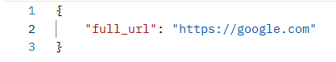
- Headers: Content-Type: application/json
- Responses: 400, 500, 201, 200
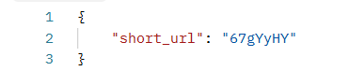

GET Redirect
- Method: GET
- Endpoint: /<short_url>
- Description: This endpoint is used for redirecting the user to the full url destination. When used, it scraps the user’s client browser, ip address to estimate its country, and saves the click time.
- Path Params: short_url (string, required) – the unique short url code.
- Query params: None
- Body: None
- Responses: 404, 302

GET Analytics
- Method: GET
- Endpoint: /api/v1/analytics/<short_url>
- Description: Provides the user with analytics for the shortened link – clicks in last 7 days, browsers used and countries clicked from.
- Path Params: short_url (string, required) – the unique short url code.
- Query params: None
- Body: None
- Responses: 404, 400, 200
